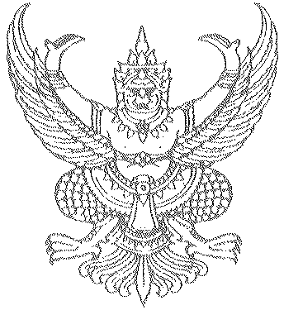
Welcome speech
Mr. Chalermpol Thanchitt
The Ambassador Extraordinary and Plenipotentiary of the Kingdom of Thailand to the Russian Federation

TCEB Russia MOU Signing Ceremony
Friday 22 April 2011

Mr Akapol Sorasuchart, the President of the Thailand Convention and Exhibition Bureau,
Mr Vladimir Strashko, Vice-President of the Chamber of Commerce and Industry of the Russian Federation.
Mr. Tokarev Vladimir, Deputy Chairman of the Russian –Thai Business Council
Members and representatives of the Thai-Russia Business Council;
Leaders of the MICE industries in Russia and Thailand;
Media representatives, Distinguished Guests, Ladies and Gentlemen;

Good morning,

It is for me a great honour and privilege to be invited to address this distinguished gathering here in the historic city of Moscow on the occasion of the signing of a Memorandum of Understanding between the Thai - Russian Business Council and Thailand Convention and Exhibition Bureau. This MOU marks the start of a major new drive to jointly promote and enhance cooperation in the Meeting, Incentive Tourism, Convention and Exhibition, or (MICE) industry.
I would therefore like to welcome all of you, and to thank you for coming here to witness this important signing ceremony. My appreciation goes also to the Thailand Convention & Exhibition Bureau or TCEB and the Thai-Russian Business Council for inviting me to join today’s proceedings and for giving me this chance to welcome you all.
As we all know, Thailand and Russia’s relationship has been a long and lasting one. Our countries’ friendship goes back more than a hundred years to 1863 when two Russian ships, the “Gaydamak” and the “Novik” shored at Bangkok Port on Chao Phraya River. Since then Russia has always been on had to protect Thailand in times of need, and formal diplomatic relations were established in 1897.
In July 2007 Her Majesty Queen Sirikit of Thailand paid a State visit to the Russian Federation on behalf of His Majesty King Bhumibol Adulyadej of Thailand, which gives some idea of the strength of our diplomatic ties. Russia is Thailand’s number one trading partner in Eastern Europe and the CIS market. Last year bilateral trade between Thailand and Russia almost doubled compared with 2009, and this vigorous growth seems set to continue this year
We may also take note that as well as being close trading partners, our two countries also share close cultural ties. Moscow is actually twinned with Bangkok as “sister cities”, and a large number of Russian tourists and business visitors visit Thailand each year.
Ladies and gentlemen,
Like many other emerging democracies around the world, the Thai people are gradually and naturally learning to express their political rights. For a time, last year’s protests caused quite some damage and disruption, and Thailand’s image of course also suffered as a result. However, I can tell you now that daily life and business have returned to normal, life goes on as usual all around the country, and tourism has bounced back strongly. Thais are resilient people, and whatever happens, Thailand will keep moving forward.
I would therefore like to take this opportunity to thank you for your support, understanding and confidence in Thailand – a country that has always been renowned for its tolerance, hospitality and love for peace.
Let me end by congratulating the Thai-Russian Business Council and TCEB for all the work you have done to make today’s signing of this MOU of cooperation possible. I am confident that today’s MOU signing will not create many new opportunities for partnerships between Russia and Thailand-based businesses, and will also will further strengthen the broader relationship between our countries. So let me stop here – once again, on behalf of the Royal Thai Government, may I welcome you all here today- thank you again for coming, and I hope that this MOU will open up new doors and new directions for your own businesses.
Thank you all for your kind attention.

